# Oracle Architecture:

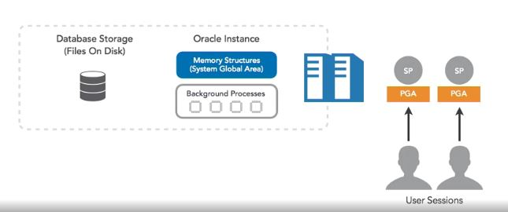

## Server Process (SP):

* Parse the SQL Statement, execute the statement.
* Check the syntax & find the best way to execute the SQL Statement.
* Read the data from database storage and load that data into Oracle instance Buffer Cache.
* Return result to user.

## Program Global Area (PGA):

* Private Memory for each user session.
* ORDER BY, GROUP BY, SORT MERGE JOIN, HASH JOIN is done at this area.
* If PGA space is inadequate, then temporary tablespace is used.

## Oracle Instance:

* SGA (System Global Area) and Background Processes.

## Database Storage:

* Store data files, redo log files, control files of the database.

## User Process (UP):

* Client Session

# Oracle Instance:

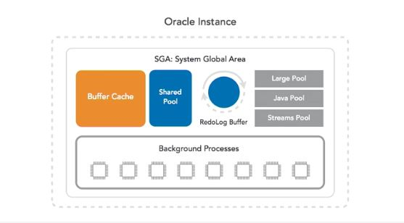

## System Global Area (SGA):

* Cache data and metadata
* **SGA_TARGET** and **SGA_MAX_SIZE** parameters determine the size of SGA
* SGA Components are:

### Shared Pool:

#### Data Dictionary Cache:

* Collection of Oracle maintained tables and views.
* Metadata about database like table definition and structure, indexing information, referential integrity and so on.
* Oracle cache this into memory to improve performance as data retrieval from memory is faster than from disk.

#### Library Cache:

* To store cache information about each SQL statement.
* Parse the SQL statement and generate the execution plan.
* Hard Parse and Cold Parse.

### Buffer Cache:

* Caching database user-data i.e. rows from tables.
* Cache blocks of data instead of rows. 1 block size = 8 kB (default)
* Read data from in-memory instead of disk to improve the performance.

### Redo log Buffer:

* Store information pertaining the changes made to the database.
* For each row modified, each redo log is generated in redo log buffer.
* Redo logs are written to disk(redo log files) immediately after user COMMITs.
* It is used for recovery of database when crashed.

### Large pool:

* Distributed transaction
* Shared server Transaction
* Parallel Operation

## Background Processes:

### Database Writer (DBWRn):

* Writing the contents from buffer cache to disk(data files).
* When will it write to DB file:
  + When there is a need to free space in buffer pool.
  + It periodically writes when database write is efficient (not when user commits)

### Log Writer (LGWR):

* Writes Redo logs from redo buffers to redo log files in disk.
* When it writes:
  + When user session commits
  + During a redo log switch
  + Redo log buffer is 1/3 full or contains atleast 1MB data
  + Before DBWRn writes buffer cache to disk
  + Every 3 seconds periodically

### Checkpoint Process (CKPT):

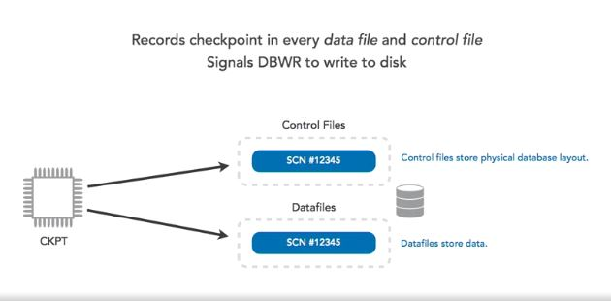

* Handles Checkpoint.
* Checkpoint is a DB event which synchronize modified data block in memory from the buffer cache with the data files on disk.
* Purpose:
  + Establish data consistency with buffer & data files(memory & disk).
  + Faster DB recovery process.
* CKPT generate SCN (System Change Number) to the control file & its data files which helps it to identify.

### System Monitor Process (SMON):

* Performs System Recovery at startup
* Cleaning unused temporary segments & reclaim those temporary segments.

### Process Monitor (PMON):

* Performs process recovery when user session or process fails.
* Release the resources that was used by failed session.
* Cleaning up changes made to blocks in the db buffer cache.

### Recovery Process (RECO):

* Distributed transaction
* Commit or Rollback on all databases.

### Listener registration (LREG):

* Registering listener to Oracle Instance.

### Archiver Process (ARCn):

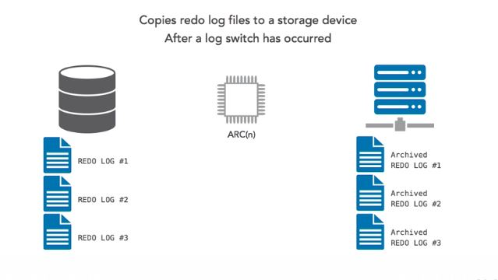

* Copies redo log files to remote storage device after a long switch has occurred.

# SGA and PGA Sizing:

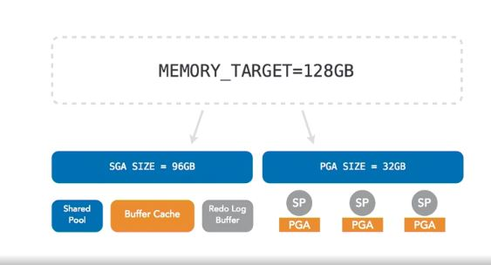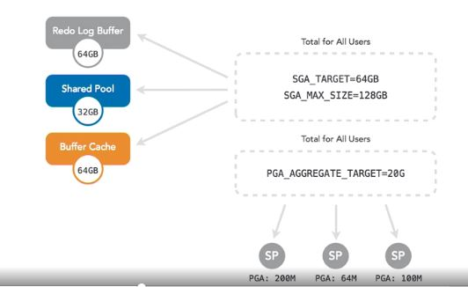

* **PGA_AGGREGATE_TARGET** parameter to allocate PGA size.
* Oracle partition SGA and PGA size dynamically by **MEMORY_TARGET** parameter.

# Oracle Listener:

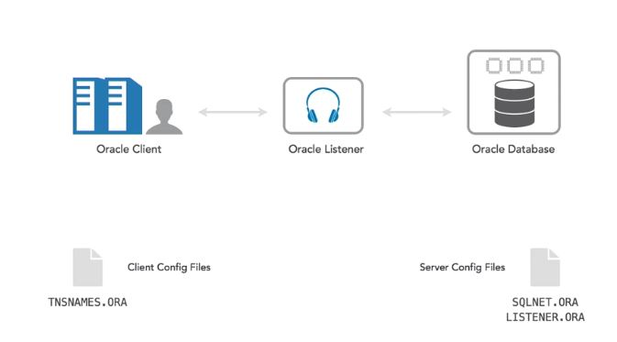

* TNSNAMES.ORA:
  + Hostname: localhost
  + Port: 1521
  + Listener Protocol: TCP
  + Service Name(SID): identify instance name
* For example:
  + ORCL = (DESCRIPTION=(ADDRESS=(PROTOCOL=TCP)(HOST=LOCALHOST)(PORT=1521)(CONNECT_DATA=SERVICE_NAME=NVAIP1)))
  + Connect sys/oracle@ORCL

# Startup Database:

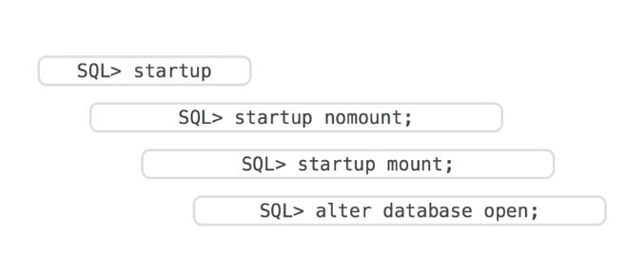

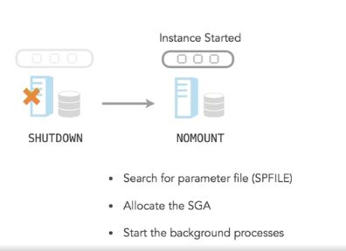

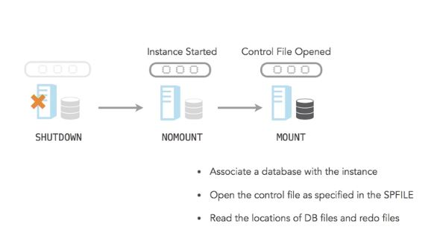

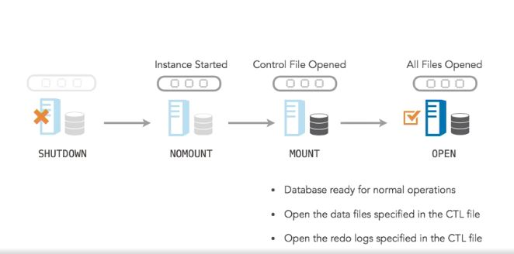

# Shutdown Database:

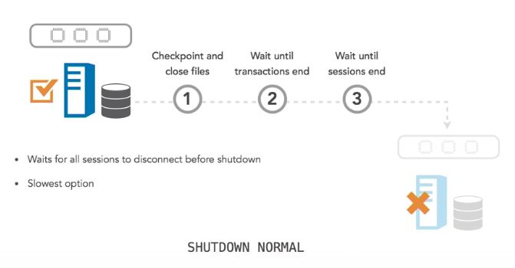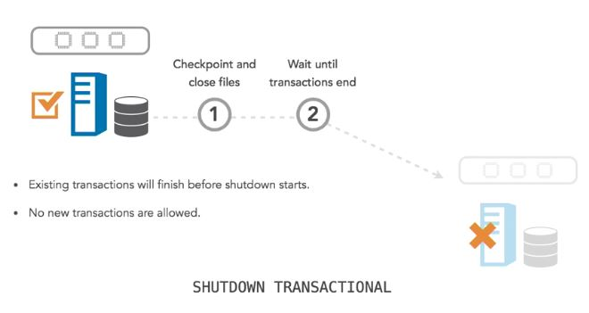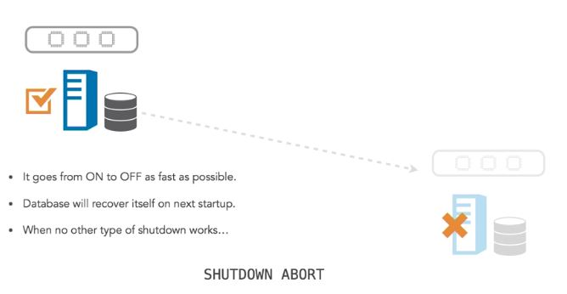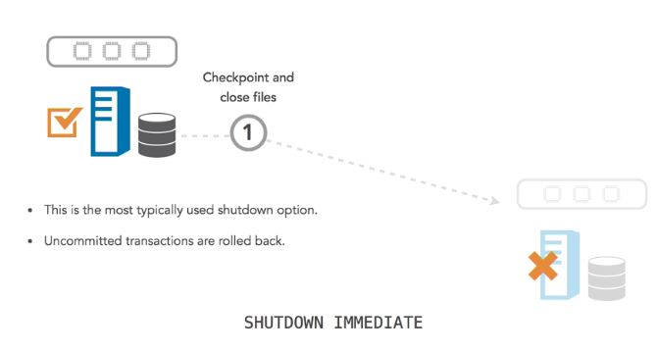

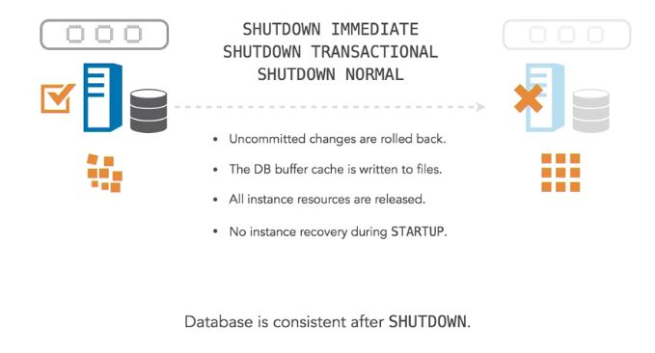

# Database Storage:

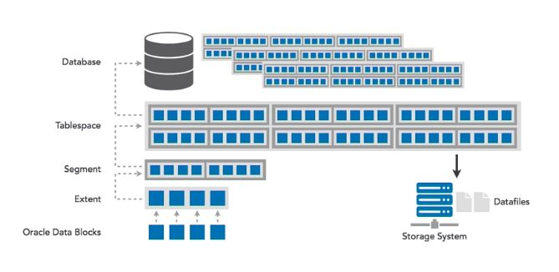

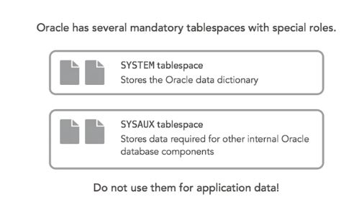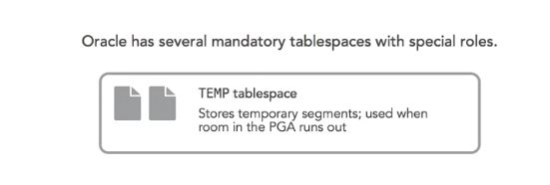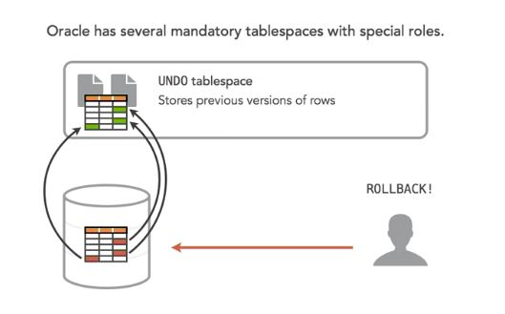

# Database Backup:

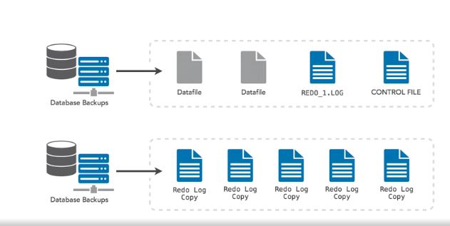

# Database Control file:

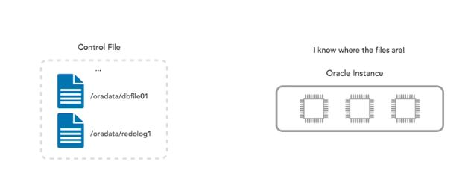

# Oracle 11g vs 12c:

